OOP
Practical 6, Week 6

Submission
- Your submission should contain two files. One of these files is PDF document with screenshots of the implementation (Java code) and testing only. Another file is ZIP file with the Java project.
- You must save the files with name
{YourStudentNumber}-Pratical6.pdf;
{YourStudentNumber}-Pratical6.zip;
For example: 202107081314-Pratical6.pdf, 202107081314-Pratical6.zip
- You must upload from the student website: student.zy.cdut.edu.cn

Marking scheme

You will gain up to 5 marks for the completion of the exercise.
The markers will use the following marking scheme for each exercise.

Rubric | marks
No attempt has been made to answer the question. No implementation at all, or completely inappropriate considerations | 0
Some attempt has been made to design the algorithm, and some considerations shown. No effort to implement a working solution and test it. | 1
Incomplete design/programming, but significant effort has gone into it. Some consideration and implementation of the result, but very limited, some of the rules have not been properly implemented, no testing. | 2
Mostly complete design but the implementation does not match the design or does not follow a correct standard. The program works but does not use loops and string methods properly. | 3
Complete design with fair to good implementation, and some testing shown. | 4
Excellent design and implementation of the whole problem, including testing and implementation. | 5

OOP
Week 6, Assessed exercise
(Details see the file “OOP Week 6 exercises.docx”)

Main program (Main class)

Based on Exercise 1 to Exercise 8 this week and code “OOP Practical 6 - Student start version” we are going to use an instance of World on the main class to store entities in our world. And, the world name is “My World” .Your main program will consist of a menu that will show all the options until the user stops with the following options:

- Ask user for the name of a Hobbit and add it to the World with default health 100
- Ask user for the name and age of a Wizard and add it to the World with wisdom 50
- Display information about the name of the World and all entities stored in that World. (Hint: the symbol of Hobbit is “#”, the symbol of Wizard is “@”. You should display the information of all the entities based on the symbols)
- Move all entities in the world about two times.
- Stop

Implement a static menu method for the menu in main program for you to call in main method.

Sample Testing Case with Four Steps and Result
(The red rectangles are the inputs)
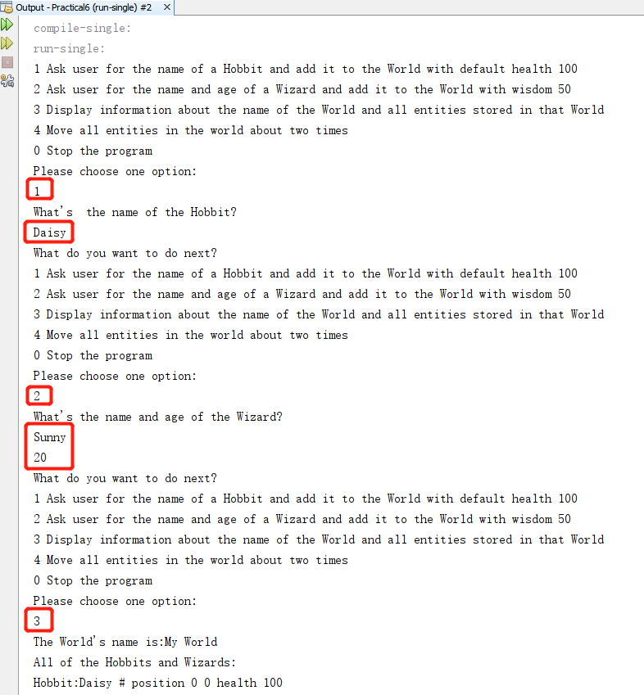
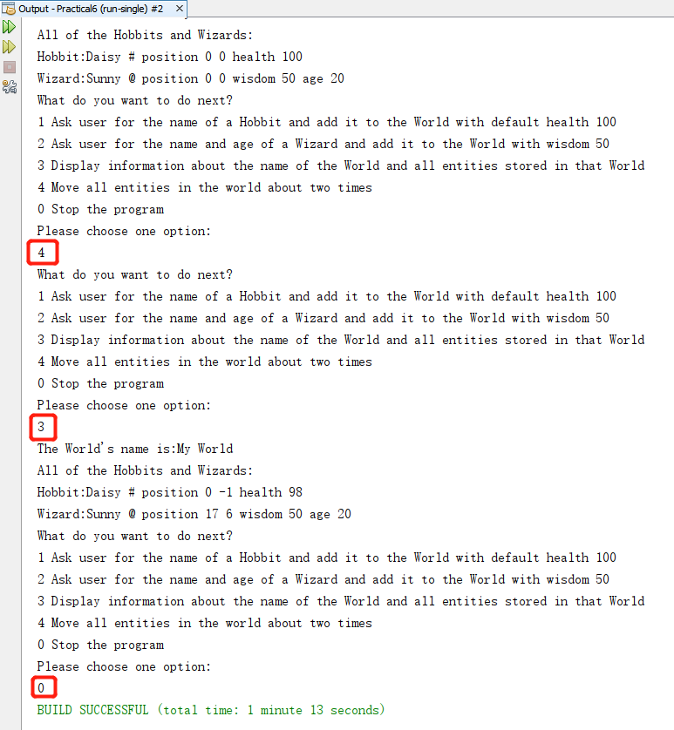

Complete the implementation and testing.
（1） Implementation

(Please show your design with some comments in your program and paste the source code of Main.java here with screenshots)

（2） Testing

Testing 1 (Same sample test case)

Testing 2 (Your own different test case – same options but different hobbit and wizard)

